**Creating Microservices for account and loan**

**ACCOUNT :**

**AccountApplication.java**

packagecom.cognizant.account;  
  
import org.springframework.boot.SpringApplication;  
import org.springframework.boot.autoconfigure.SpringBootApplication;  
  
@SpringBootApplication  
public class AccountApplication{  
  
public static void main(String[] args) {  
SpringApplication.*run*(AccountApplication.class, args);  
 }  
  
}

**AccountController.java**

package com.cognizant.account.controller;  
import org.springframework.web.bind.annotation.GetMapping;  
import org.springframework.web.bind.annotation.PathVariable;  
import org.springframework.web.bind.annotation.RestController;  
  
import java.util.Map;  
  
@RestController  
public class AccountController{  
@GetMapping("/accounts/{number}")  
public Map<String, Object>getAccountDetails(@PathVariableString number) {  
return Map.*of*(  
"number", number,  
"type", "savings",  
"balance", 234343  
);  
 }  
}

**Pom.XML**

*<?*xml version="1.0" encoding="UTF-8"*?>*<project xmlns="http://maven.apache.org/POM/4.0.0" xmlns:xsi="http://www.w3.org/2001/XMLSchema-instance"  
xsi:schemaLocation="http://maven.apache.org/POM/4.0.0 https://maven.apache.org/xsd/maven-4.0.0.xsd">  
<modelVersion>4.0.0</modelVersion>  
<parent>  
<groupId>org.springframework.boot</groupId>  
<artifactId>spring-boot-starter-parent</artifactId>  
<version>3.5.3</version>  
<relativePath/>*<!-- lookup parent from repository -->*</parent>  
<groupId>com.cognizant</groupId>  
<artifactId>account</artifactId>  
<version>0.0.1-SNAPSHOT</version>  
<name>account</name>  
<description>Demo project for Spring Boot</description>  
<url/>  
<licenses>  
<license/>  
</licenses>  
<developers>  
<developer/>  
</developers>  
<scm>  
<connection/>  
<developerConnection/>  
<tag/>  
<url/>  
</scm>  
<properties>  
<java.version>21</java.version>  
</properties>  
<dependencies>  
<dependency>  
<groupId>org.springframework.boot</groupId>  
<artifactId>spring-boot-starter-web</artifactId>  
</dependency>  
  
<dependency>  
<groupId>org.springframework.boot</groupId>  
<artifactId>spring-boot-devtools</artifactId>  
<scope>runtime</scope>  
<optional>true</optional>  
</dependency>  
<dependency>  
<groupId>org.springframework.boot</groupId>  
<artifactId>spring-boot-starter-test</artifactId>  
<scope>test</scope>  
</dependency>  
</dependencies>  
  
<build>  
<plugins>  
<plugin>  
<groupId>org.springframework.boot</groupId>  
<artifactId>spring-boot-maven-plugin</artifactId>  
</plugin>  
</plugins>  
</build>  
  
</project>

**OUTPUT:**

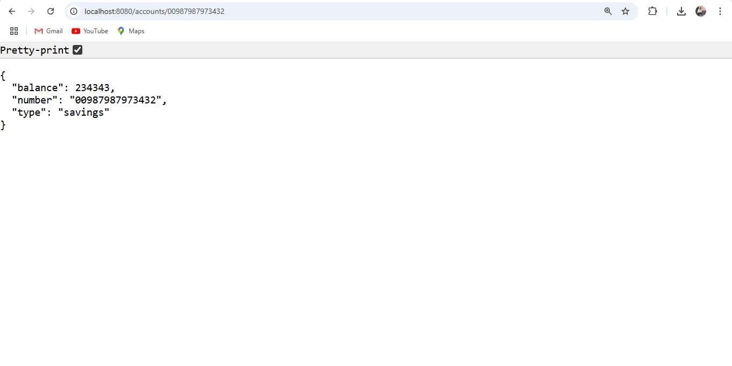**LOAN:**

**LoanApplication.java**

packagecom.cognizant.loan;  
  
import org.springframework.boot.SpringApplication;  
import org.springframework.boot.autoconfigure.SpringBootApplication;  
  
@SpringBootApplication  
public class LoanApplication{  
  
public static void main(String[] args) {  
SpringApplication.*run*(LoanApplication.class, args);  
 }  
  
}

**LoanController.java**

package com.cognizant.loan.controller;  
import org.springframework.web.bind.annotation.GetMapping;  
import org.springframework.web.bind.annotation.PathVariable;  
import org.springframework.web.bind.annotation.RestController;  
  
import java.util.Map;  
  
@RestController  
public class LoanController{  
  
@GetMapping("/loans/{number}")  
public Map<String, Object>getLoanDetails(@PathVariableString number) {  
return Map.*of*(  
"number", number,  
"type", "car",  
"loan", 400000,  
"emi", 3258,  
"tenure", 18  
);  
 }  
}

**ApplicationProperties**

spring.application.name=loan  
server.port=8081

**Pom.XML**

*<?*xml version="1.0" encoding="UTF-8"*?>*<project xmlns="http://maven.apache.org/POM/4.0.0" xmlns:xsi="http://www.w3.org/2001/XMLSchema-instance"  
xsi:schemaLocation="http://maven.apache.org/POM/4.0.0 https://maven.apache.org/xsd/maven-4.0.0.xsd">  
<modelVersion>4.0.0</modelVersion>  
<parent>  
<groupId>org.springframework.boot</groupId>  
<artifactId>spring-boot-starter-parent</artifactId>  
<version>3.5.3</version>  
<relativePath/>*<!-- lookup parent from repository -->*</parent>  
<groupId>com.cognizant</groupId>  
<artifactId>loan</artifactId>  
<version>0.0.1-SNAPSHOT</version>  
<name>loan</name>  
<description>Demo project for Spring Boot</description>  
<url/>  
<licenses>  
<license/>  
</licenses>  
<developers>  
<developer/>  
</developers>  
<scm>  
<connection/>  
<developerConnection/>  
<tag/>  
<url/>  
</scm>  
<properties>  
<java.version>21</java.version>  
</properties>  
<dependencies>  
<dependency>  
<groupId>org.springframework.boot</groupId>  
<artifactId>spring-boot-starter-web</artifactId>  
</dependency>  
  
<dependency>  
<groupId>org.springframework.boot</groupId>  
<artifactId>spring-boot-devtools</artifactId>  
<scope>runtime</scope>  
<optional>true</optional>  
</dependency>  
<dependency>  
<groupId>org.springframework.boot</groupId>  
<artifactId>spring-boot-starter-test</artifactId>  
<scope>test</scope>  
</dependency>  
</dependencies>  
  
<build>  
<plugins>  
<plugin>  
<groupId>org.springframework.boot</groupId>  
<artifactId>spring-boot-maven-plugin</artifactId>  
</plugin>  
</plugins>  
</build>  
  
</project>

**OUTPUT:**

